Lab 07

Part 1

1.) Using a spreadsheet is an inefficient way to store data. Its hard to maintain and update the data. Their is no way to query the data set. Their is no way to verify and efforce the integrity of the data. It is also insecure. This data should be stored in a database. This will
provide all the above mentioned functionality.

2.)

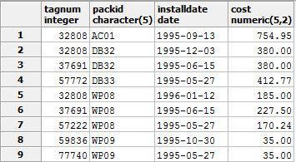

- ) The primary key is a composite key of "TagNum" and "PackID" (TagNum, PackID).

Part 2

- )

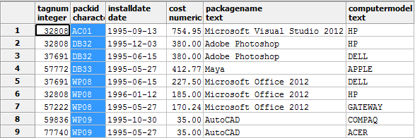

- ) TagNum -> ComputerModel
PackID -> PackageName
PackageName -> PackID
TagNum, PackID -> * The set and all subsets of
{ Install Date, Cost, PackageName, ComputerModel }

- ) This table is not in NF3, as it violates NF2. This is due to a violation of a non-prime attribute being dependent on just part of the candidate key for this table. These non-prime attributes are ComputerModel (dependent on TagNum), and PackageName (dependent on PackID). Both TagNum and PackageName are subsets of the candidate key, violating NF2.

Part 3

- ) Table 'software_packages' primary key is 'PackID'. Table 'assets' primary key is 'TagNum' . Table 'installations' primary key is a composite key, (TagNum,PackID).

- ) 'software_packages' :
Packid -> Name
Name -> PackID

'assets' :
TagNum -> ComputerModel

'installations' :
TagNum, PackID -> * The set and all subsets of { Install Date, Cost }

- ) First, the tables are now in NF2. Second, there only transient dependencies where (A->B and B->A). There are no transient dependencies in the form A->B and B->C so A->C, where A != C.

- )

